Now we are going to talk about JSX in React Native

Now above It is written in brackets that JSX is the powerhouse of React
is absolutely correct
because if there was no jsx then we would have to write complicated codes in React native or Reeact js and because of this our code gets simple and our time gots saved and we can easily understand React native or react js code
It is inbuilt inside it we don't have to install it seperately
Now you can ask Is it difficult to learn
No in this lesson you will understand jsx completely and as we read react native you will master in react js
At firstt teacher will tell us what is JSX. We will take an example of it, and teacher will tell us about Interesting fact about JSX
If you tell these facts to the interviewer then he will be impressed and he will thign you have very high knowledge of React Native or jsx'
Nowe we start with first question that is what is jsx
Its full form means is Javascript extension
means inside Javascript some extra features are added and called it JSX but what is its benefit
that is you can write HTML code in javscript
So did we earlier before JSX could not write HTML code in Javascript and why did the HTML come in between when we are actually studying in React Native
when we are talking about JSX

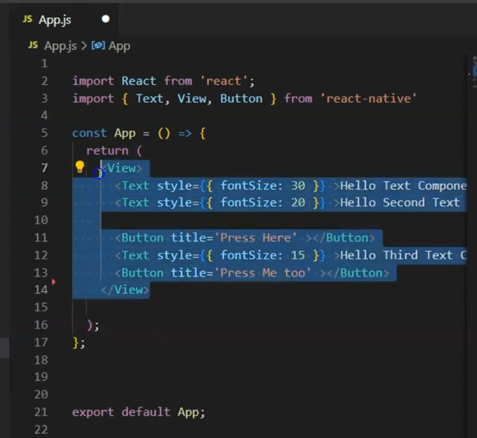

We are assuming that seleced above in JSX is HTML
Teacher knows these are component but if we talk about react js then jhere HTML comes
So to understand simply we are assuming it so that it will be easier for you to understand
So what used to happen before occurance of JSX you could not write HTML in your JSX
you had to write them seperately How how you did it
Teacher is saying an example
If you have studies some javvascript then you must have seen
document.getElementById() or innerHTML or getElementsByClassName
So what we used to do is wwe make a scriupt tag in html ot make a seperate file for HTML aand make a seperate file for js and a seperate file for HTML and we combine them with the help of their id or class
ou could not mix matched them
You cannot write HTML in the script tag
Make a seperate page and try to use HTML in script tags or maake a js file and try to write HTML inside it you will get an error and you could not write there
So this is teh feature of JSX thatit allows HTML inside Javascript
If we talk specifically about React Native trhen it allows Component in Javscript
Now what ois teh benefit of it
Now suppose in below JSX

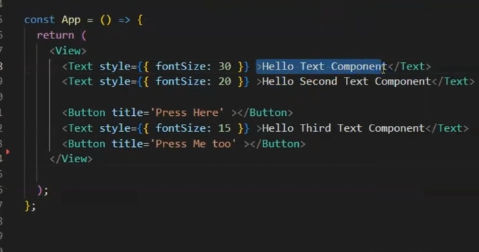
In the selected Text you want to print variable in place of selected text or want to return something their by function and want to apply condition
then you would have give that element an id and give class and inside script tag and later print something in it or with the help of inner.HTMl or inner.tet forcefully push the variable there
but here you don't need to do domething there
How it i used and what is the syntax Teacher will show it to you
So now you understand it is extension of Javascript that allows HTML tags ot React native components inside Javascript
Now suppose we have a variable
Teacher is not teaching stated props for now
becasue we are goin step by step now
Suppose we have a constant and we name it name and give it value "anil" and also declare a varibable with let named age and give it value 29 and also decalre a varibale var and name it as email since we use three types of varibale and constant declaration in javascript we gieve email value that is "abc@test.com" as shown below

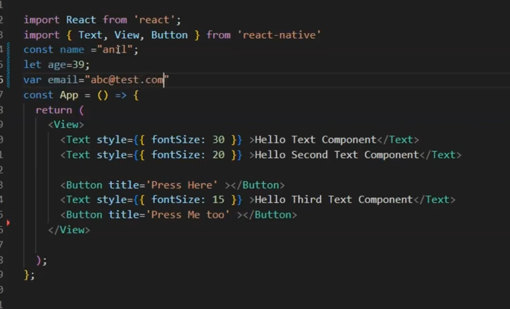

Suppose if there was no JSX then i would have to give id to the element and then with the help of innerHTML and innerText we have to push it but here it is very simple
5:05

you just use the varibale in JSX in between the curly brackets as shown below
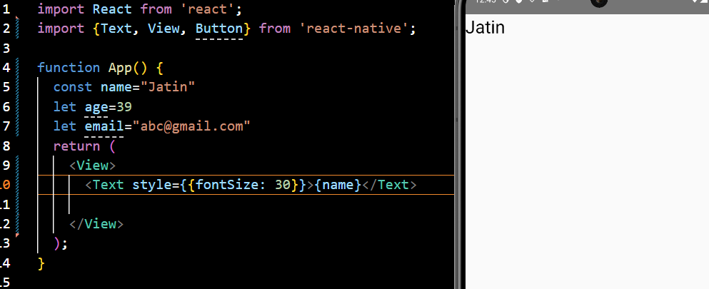

Note:-

You can use the variable inside the component (function) or outside it

Now as ou done with name ou can do for age and email

even if ou make function and it return somthing and you call it it between the curly braces then the out pur still will be shown as shon below

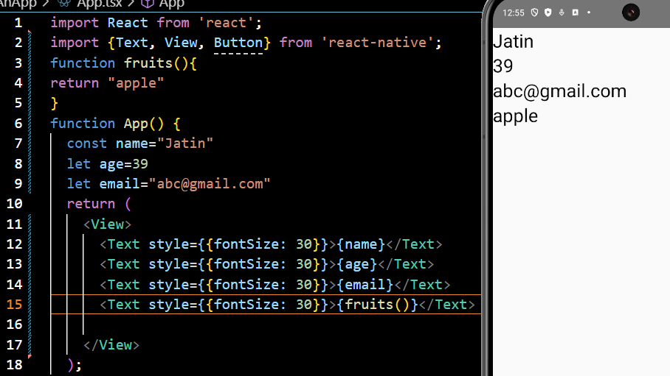
Ther are many things suppose if you have two values or operand and you perform operation on tehm then there result will be shown for example if we add 100 and 20 then teh result will be 120

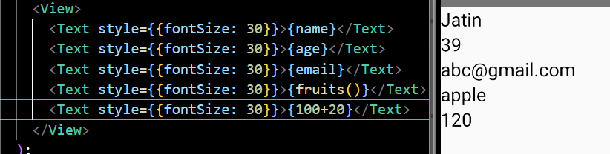
you can do other operation here also
Instead you can also apply condition with the help of conditional operator
as shown below

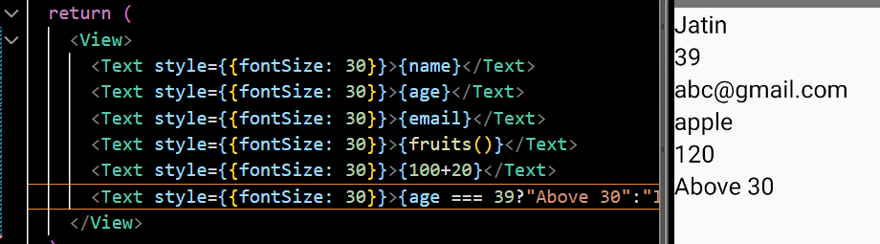
Now if you change the age to 3 then the result shown will Invalide number

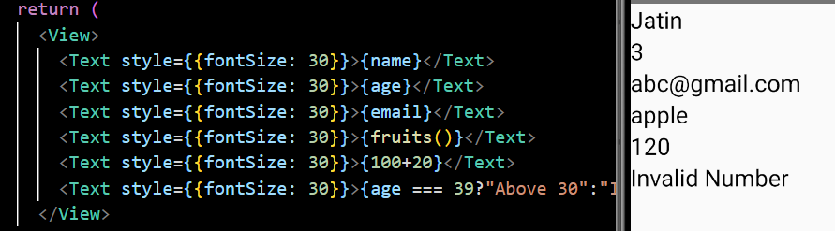

Teacher will tell us how to loops here but later
Eventually we will learn but we have covered basic thing that how jsx work
We can write jsvacrikpt between the tags here and we can do html in javascript file as well

Now Interesting facts about JSX

If you try to ind the fulll form of JSX then unofficial site it will say that its full form is
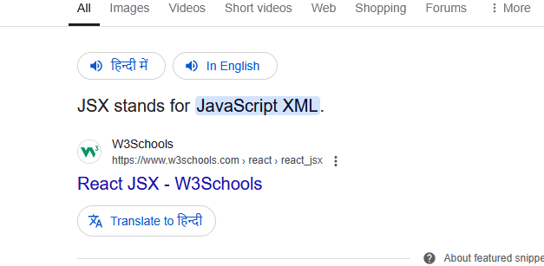
but in official Doc

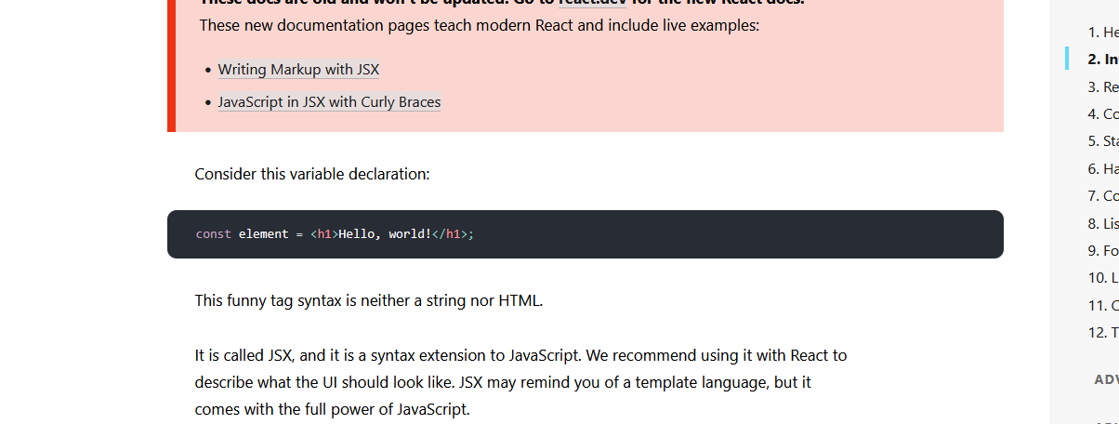
It just says it tis the extension of Javascript
if you research JSX npm(github(I don't know)) then still there is no mention that it is Javascsript XML or extension

SO if someine ask you intervieww question
Then you can answer that in in unoffial site it is Javascript XML but in official documentation it is extension of Javascript So there are chances that it could be Javascript extension and apart from it some question could be that what is the use of XML . Do ou need to install XML seperatley
No it is installed inside it
Now it will be sasekd can you declare function in between tags no you can only call them here
They can ask you syntax
IN syntax you an say ther is simple double curly braces and in between them you can write javascript

